**DAILY ONLINE ACTIVITIES SUMMARY**

|  |  |  |  |  |  |  |  |  |
| --- | --- | --- | --- | --- | --- | --- | --- | --- |
| **Date:** | **07/08/2020** | | | | | **Name:** | **Spoorthy Balaji** | |
| **Sem & Sec** | **6th & B** | | | | | **USN:** | **4al17cs098** | |
| **Online Test Summary** | | | | | | | | |
| **Subject** | | **-** | | | | | | |
| **Max. Marks** | | **-** | | **Score** | | | **-** | |
| **Certification Course Summary** | | | | | | | | |
| **Course** | **Salesforce Trailhead** | | | | | | | |
| **Certificate Provider** | | | **-** | | **Duration** | | | **-** |
| **Coding Challenges** | | | | | | | | |
| **Problem Statement: Python Program for Check if all digits of a number divide it** | | | | | | | | |
| **Status: Solved** | | | | | | | | |
| **Uploaded the report in Github** | | | | | **yes** | | | |
| **If yes Repository name** | | | | | <https://github.com/spoorthybalaji/Daily_Status> | | | |
| **Uploaded the report in slack** | | | | | **yes** | | | |

**ONLINE COURSE**

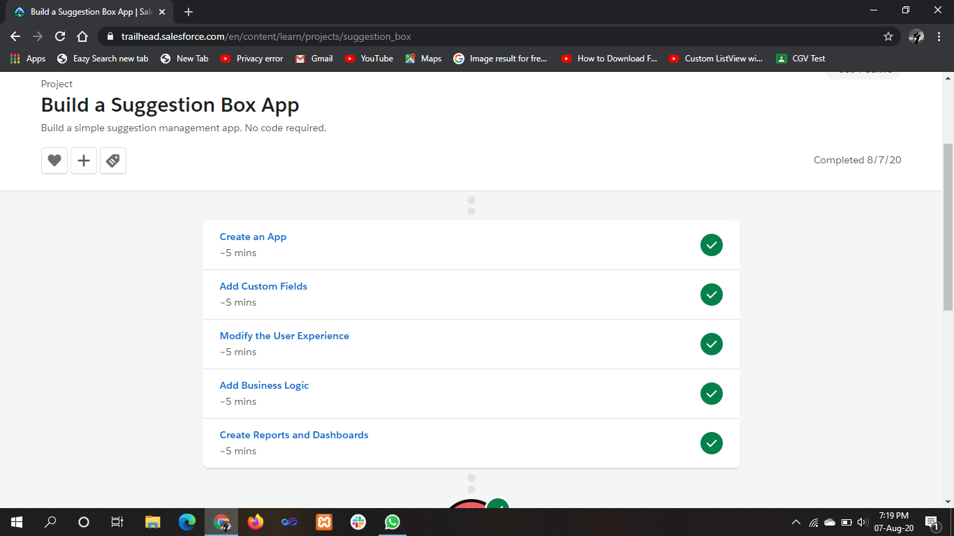

.

**ONLINE** **CODING**

**Python Program for Check if all digits of a number divide it**

**def checkDivisibility(n, digit) :**

**return (digit != 0 and n % digit == 0)**

**def allDigitsDivide( n) :**

**temp = n**

**while (temp > 0) :**

**digit = n % 10**

**if ((checkDivisibility(n, digit)) == False) :**

**return False**

**temp = temp // 10**

**return True**

**n = 128**

**if (allDigitsDivide(n)) :**

**print("Yes")**

**else :**

**print("No" )**

